Course Title : Big Data Analytics
Course Code : Z1AMC 702
Name: Jayman Prajapati Registration No: 2511042210016

Experiment 4: Word Count of All Files Using Hadoop MapReduce

- Objective

To perform a Word Count operation on multiple text files stored in HDFS using the Hadoop MapReduce framework and display the frequency of each word.

- Procedure

Step 1: Create Input Text Files

Create multiple text files containing sample text data
file1.txt
Content for file one

file2.txt
Content for file two

file3.txt
Content for file three

Step 2: Verify the Files

ls -la file*.txt

Step 3: Create HDFS Input Directory

hdfs dfs -mkdir -p /jayman/hadoop_file/input

Step 4: Upload Files to HDFS

hdfs dfs -put *.txt /jayman/hadoop_file/input/

Step 5: Run the Word Count Program

hadoop jar $HADOOP_HOME/share/hadoop/mapreduce/hadoop-mapreduce-examples-*.jar wordcount \
/jayman/hadoop_file/input \
/jayman/hadoop_file/output

Step 6: View the Output

hdfs dfs -cat /jayman/hadoop_file/output/part-r-00000
3) Source Code
hadoop jar $HADOOP_HOME/share/hadoop/mapreduce/hadoop-mapreduce-examples-*.jar wordcount input output

4) Screen Short
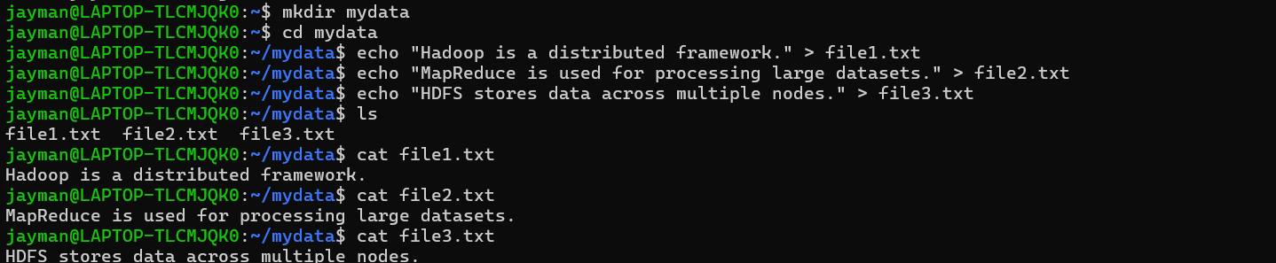
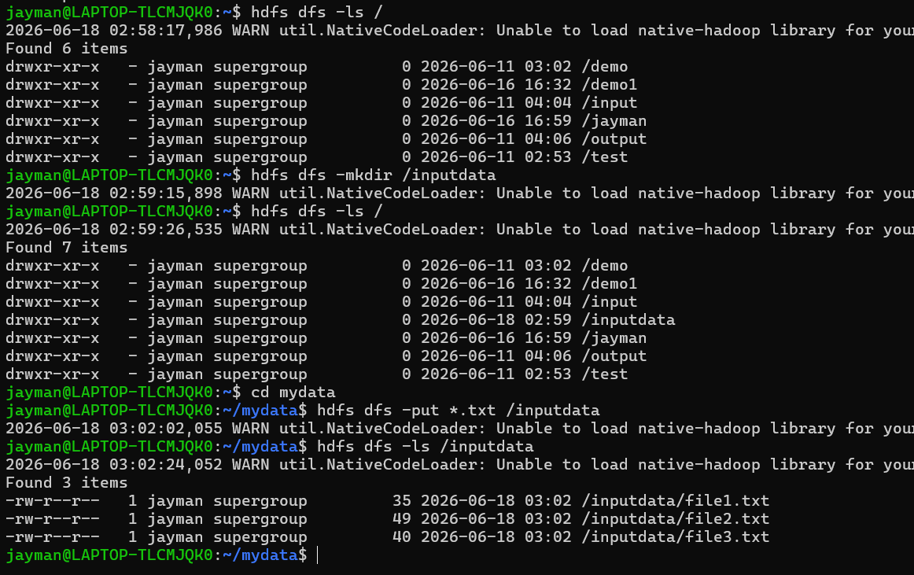
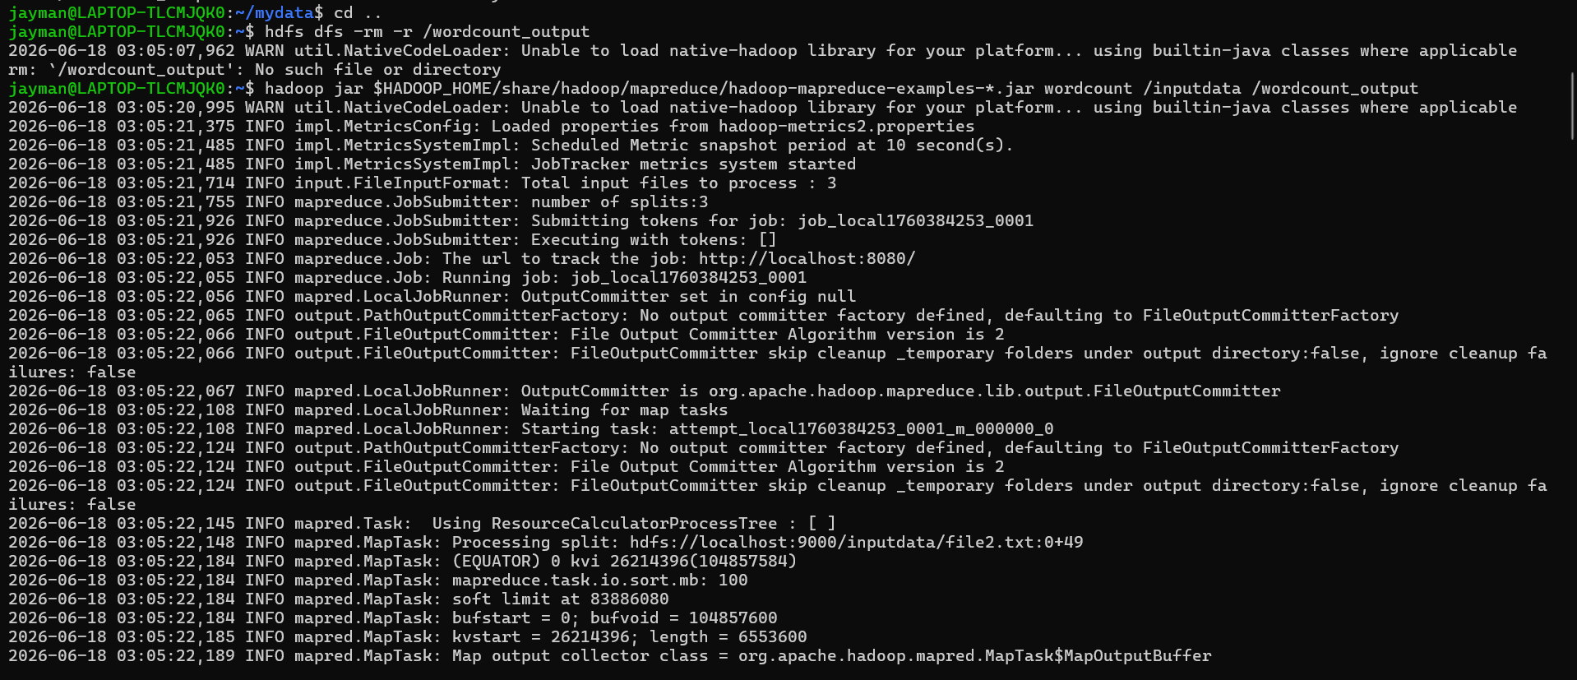
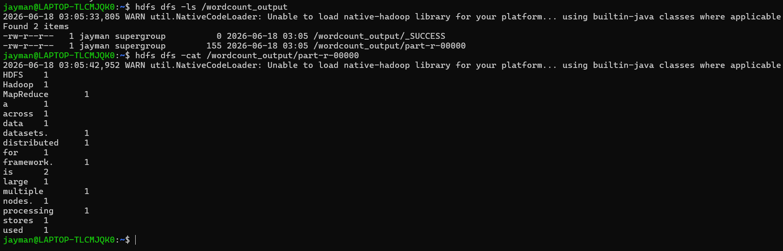

5) Conclusion
The Word Count MapReduce program was successfully executed on multiple text files stored in HDFS. Hadoop processed the files in a distributed manner and generated the frequency count of each word. The experiment demonstrated the working of the Map and Reduce phases and showed how Hadoop can efficiently process large datasets.

Exercise 5: Custom MapReduce with Hadoop Streaming

  - Objective
Main Goal
To analyze a large sales dataset (50,000 records) using custom Python scripts with Hadoop Streaming, demonstrating the MapReduce paradigm for big data processing.
Specific Objectives:
- Generate a realistic sales dataset for analysis
- Write custom Python Mapper and Reducer scripts
- Process data using Hadoop Streaming
- Analyze sales by city, monthly trends, and product performance
- Extract meaningful business insights from the data
2) Procedure
Step 1: Environment Setup
Step 2: Generate Dataset (50,000 Records)
Step 3: Create Mapper Script (Sales by City)
Step 4: Create Reducer Script (Sum by City)
Step 5: Local Testing
Step 6: Upload to HDFS
Step 7: Run Hadoop Streaming Job
Step 8: Analyze Results
Step 9: Additional Analysis - Monthly Sales

  - Source Code

# Create Python script to generate sales data
cat > generate_sales.py << 'EOF'
import random
import datetime

products = ['Laptop', 'Mouse', 'Keyboard', 'Monitor', 'Headphones', 'Webcam', 'Printer', 'Scanner']
cities = ['Mumbai', 'Delhi', 'Bangalore', 'Chennai', 'Hyderabad', 'Pune', 'Kolkata', 'Ahmedabad']
customers = [f'CUST{str(i).zfill(5)}' for i in range(1, 1001)]

start_date = datetime.date(2024, 1, 1)
end_date = datetime.date(2024, 12, 31)
date_range = (end_date - start_date).days

for i in range(50000):
date = start_date + datetime.timedelta(days=random.randint(0, date_range))
product = random.choice(products)
price = round(random.uniform(100, 5000), 2)
city = random.choice(cities)
customer = random.choice(customers)
quantity = random.randint(1, 5)
print(f"{date},{product},{price},{city},{customer},{quantity}")
EOF

# Generate data
python3 generate_sales.py > sales_data.csv

cat > mapper_city_sales.py << 'EOF'
#!/usr/bin/env python3
import sys

for line in sys.stdin:
line = line.strip()
if not line:
continue

parts = line.split(',')
if len(parts) != 6:
continue

try:
date = parts[0]
product = parts[1]
price = float(parts[2])
city = parts[3]
customer = parts[4]
quantity = int(parts[5])

total = price * quantity
print(f"{city}\t{total}")
except ValueError:
continue
EOF

chmod +x mapper_city_sales.py

cat > reducer_city_sales.py << 'EOF'
#!/usr/bin/env python3
import sys

current_city = None
total_sales = 0
count = 0

for line in sys.stdin:
line = line.strip()
if not line:
continue

city, amount = line.split('\t')
amount = float(amount)

if city == current_city:
total_sales += amount
count += 1
else:
if current_city is not None:
print(f"{current_city}\t{total_sales:.2f}\t{count}")
current_city = city
total_sales = amount
count = 1

if current_city is not None:
print(f"{current_city}\t{total_sales:.2f}\t{count}")
EOF

chmod +x reducer_city_sales.py

# Test with sample data
head -20 sales_data.csv | python3 mapper_city_sales.py | sort | python3 reducer_city_sales.py
# Create HDFS directories
hdfs dfs -mkdir -p /user/$USER/sales/input

# Upload data
hdfs dfs -put sales_data.csv /user/$USER/sales/input/

# Verify
hdfs dfs -ls /user/$USER/sales/input/

  - Screen Shorts
Part-1: Generate a Larger Dataset
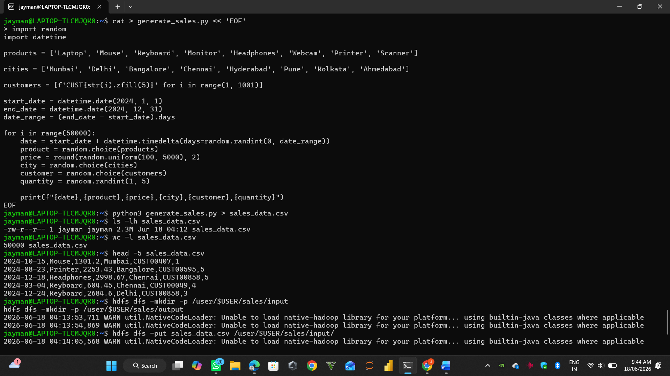
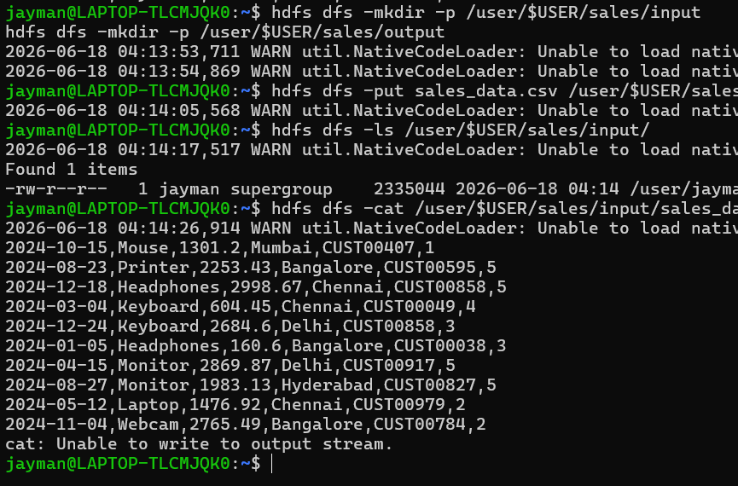
Part-2: Mapper Script - Sales by City
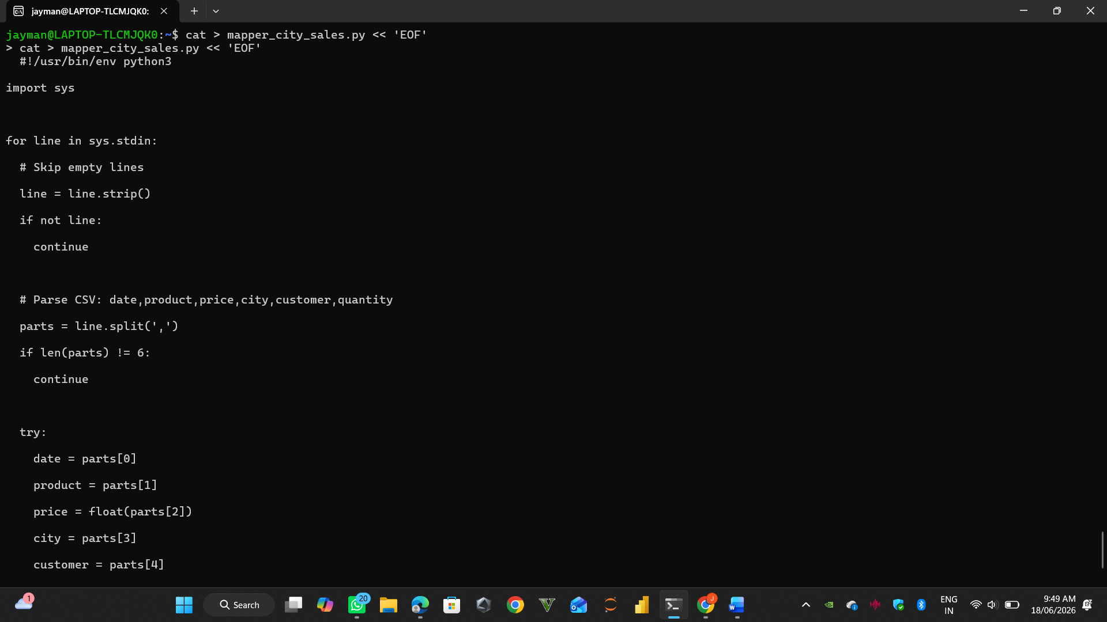
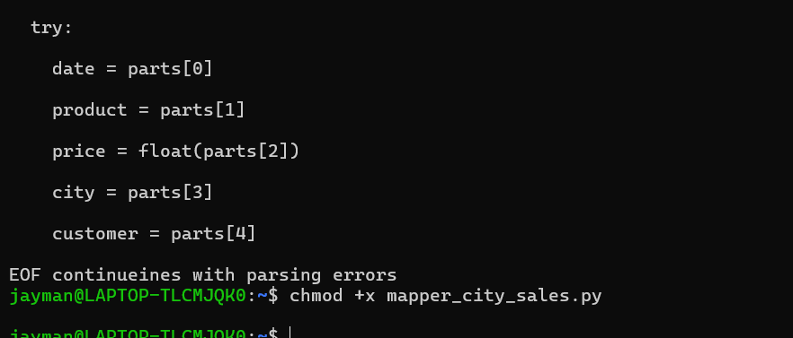

Part-3: Reducer Script - Sum by City
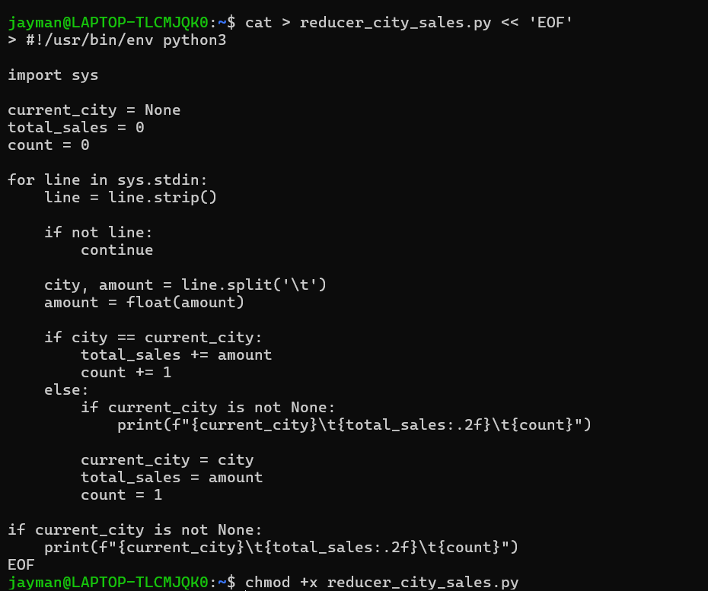
Part 4: Test Locally
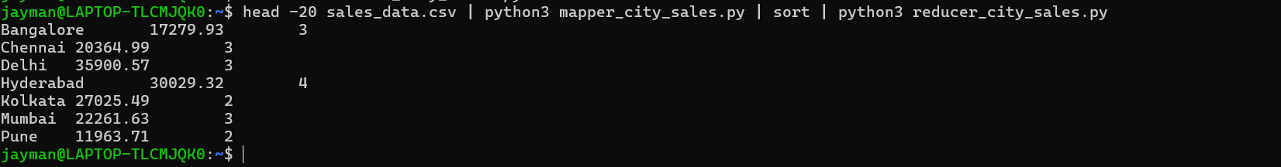
Part 5: Run on Hadoop
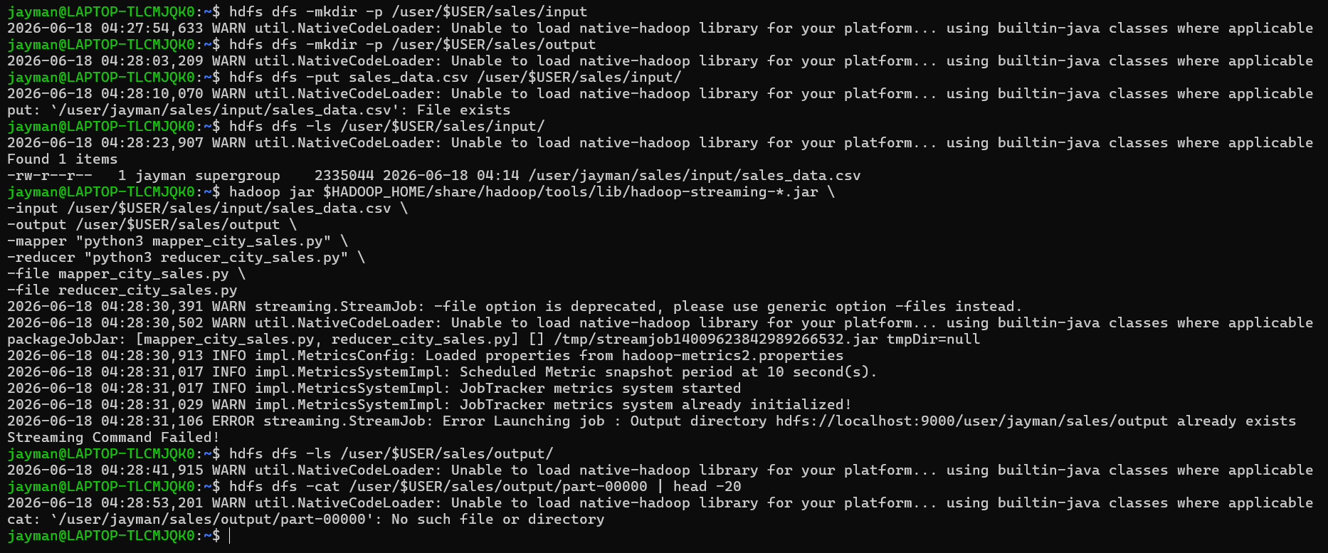
Part 6: Analyze Results
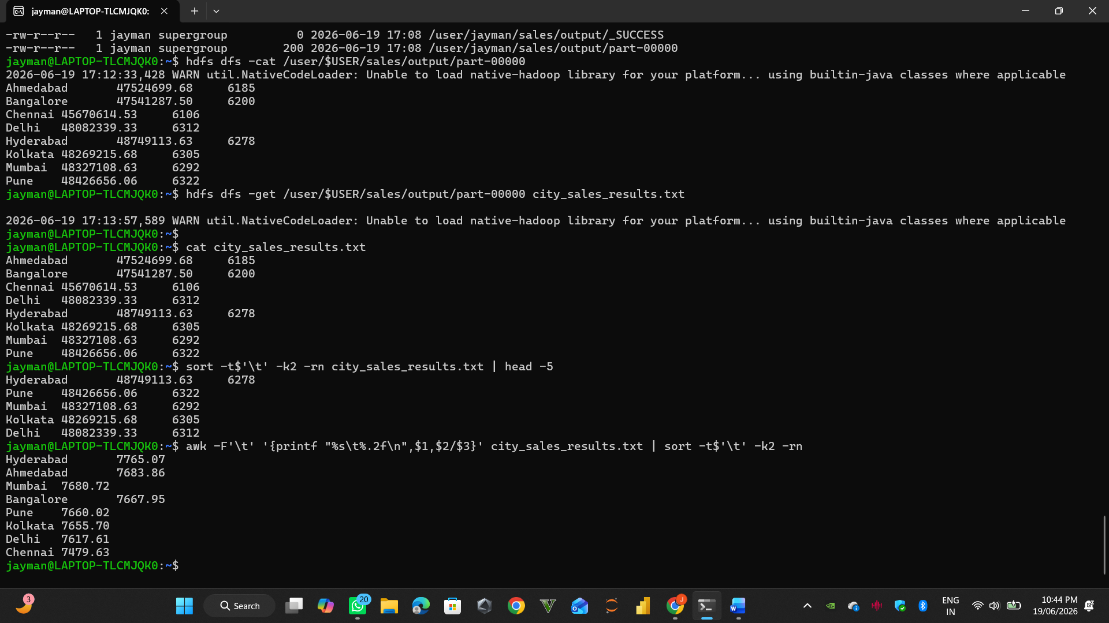
Part-7:
7.1: Monthly Sales Analysis
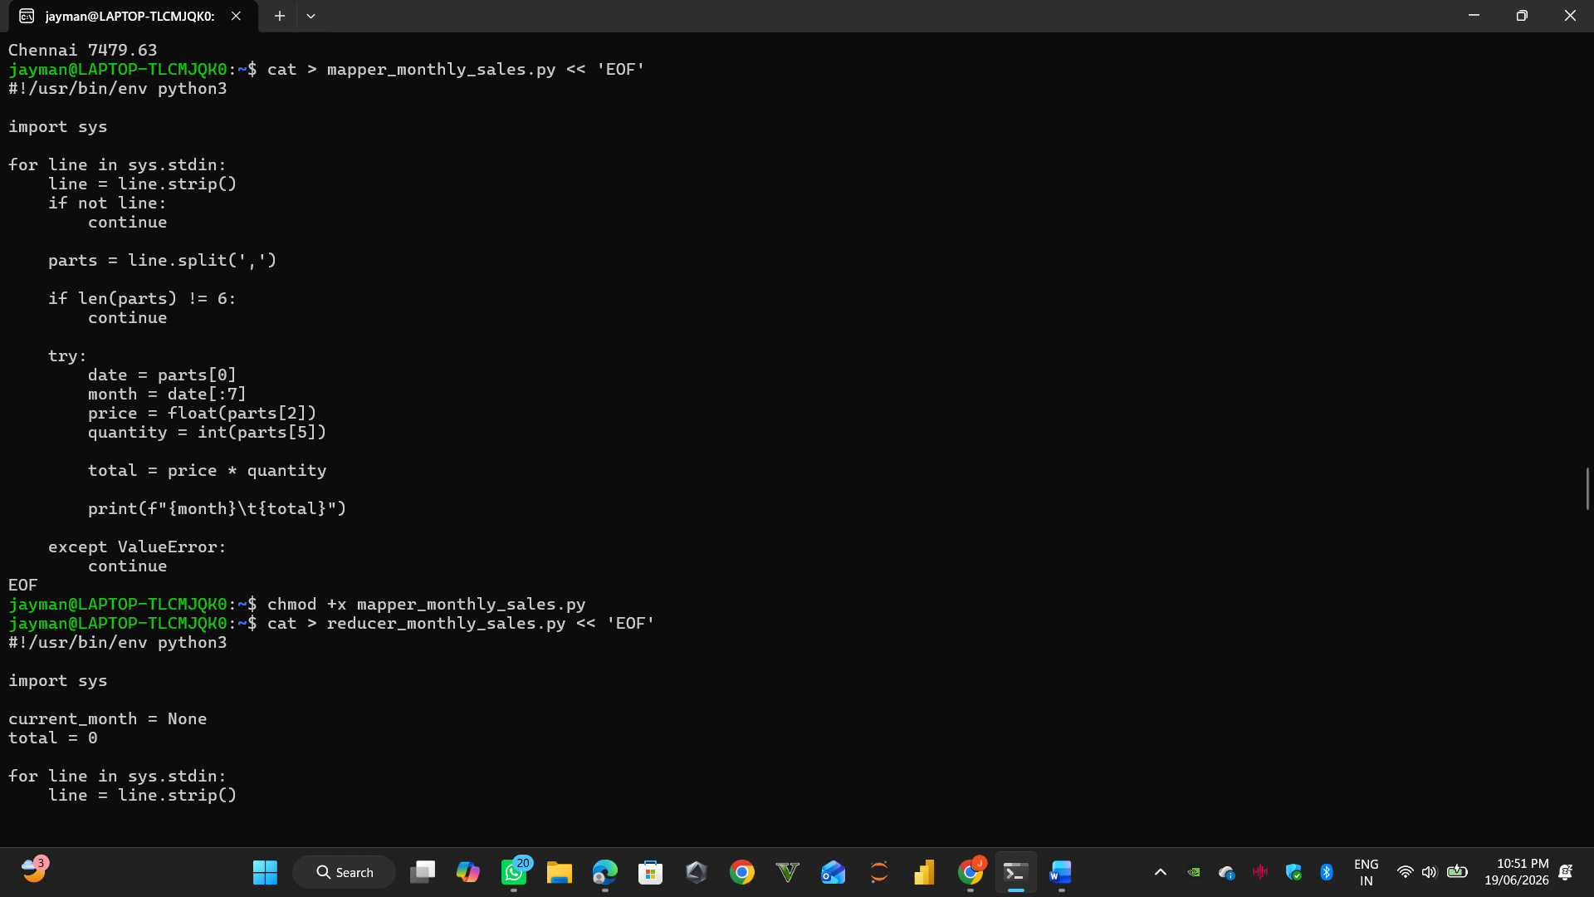
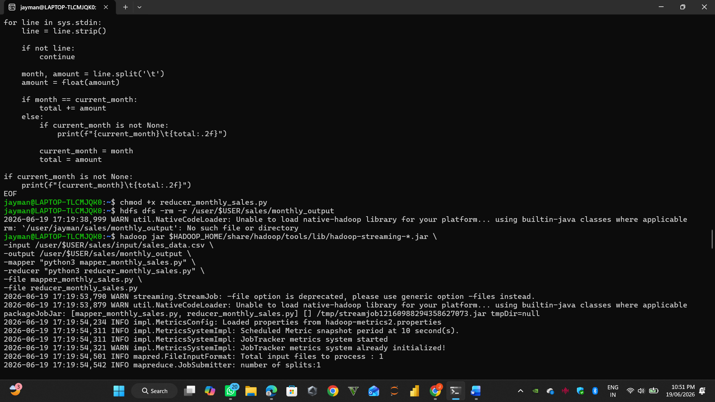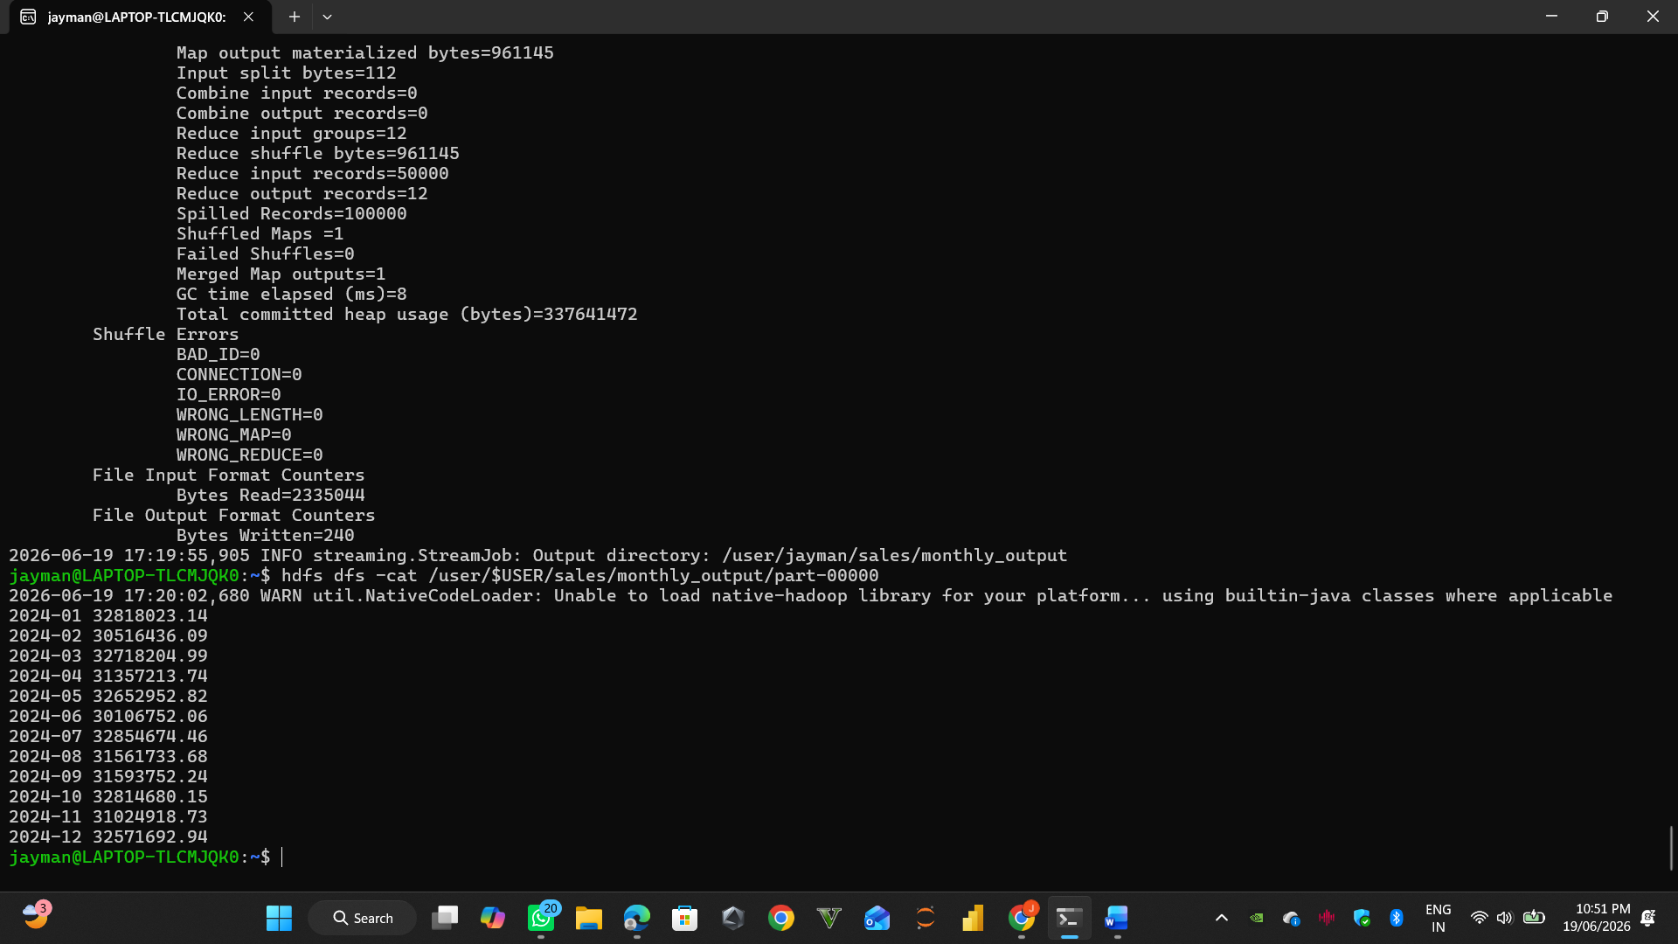

7.2: Product Analysis
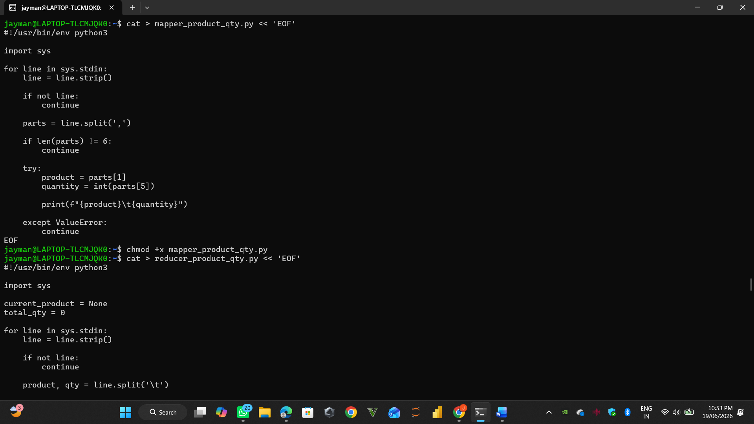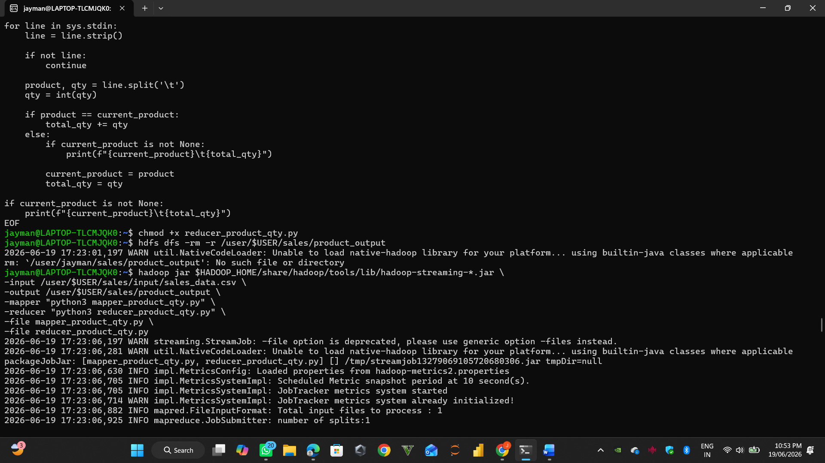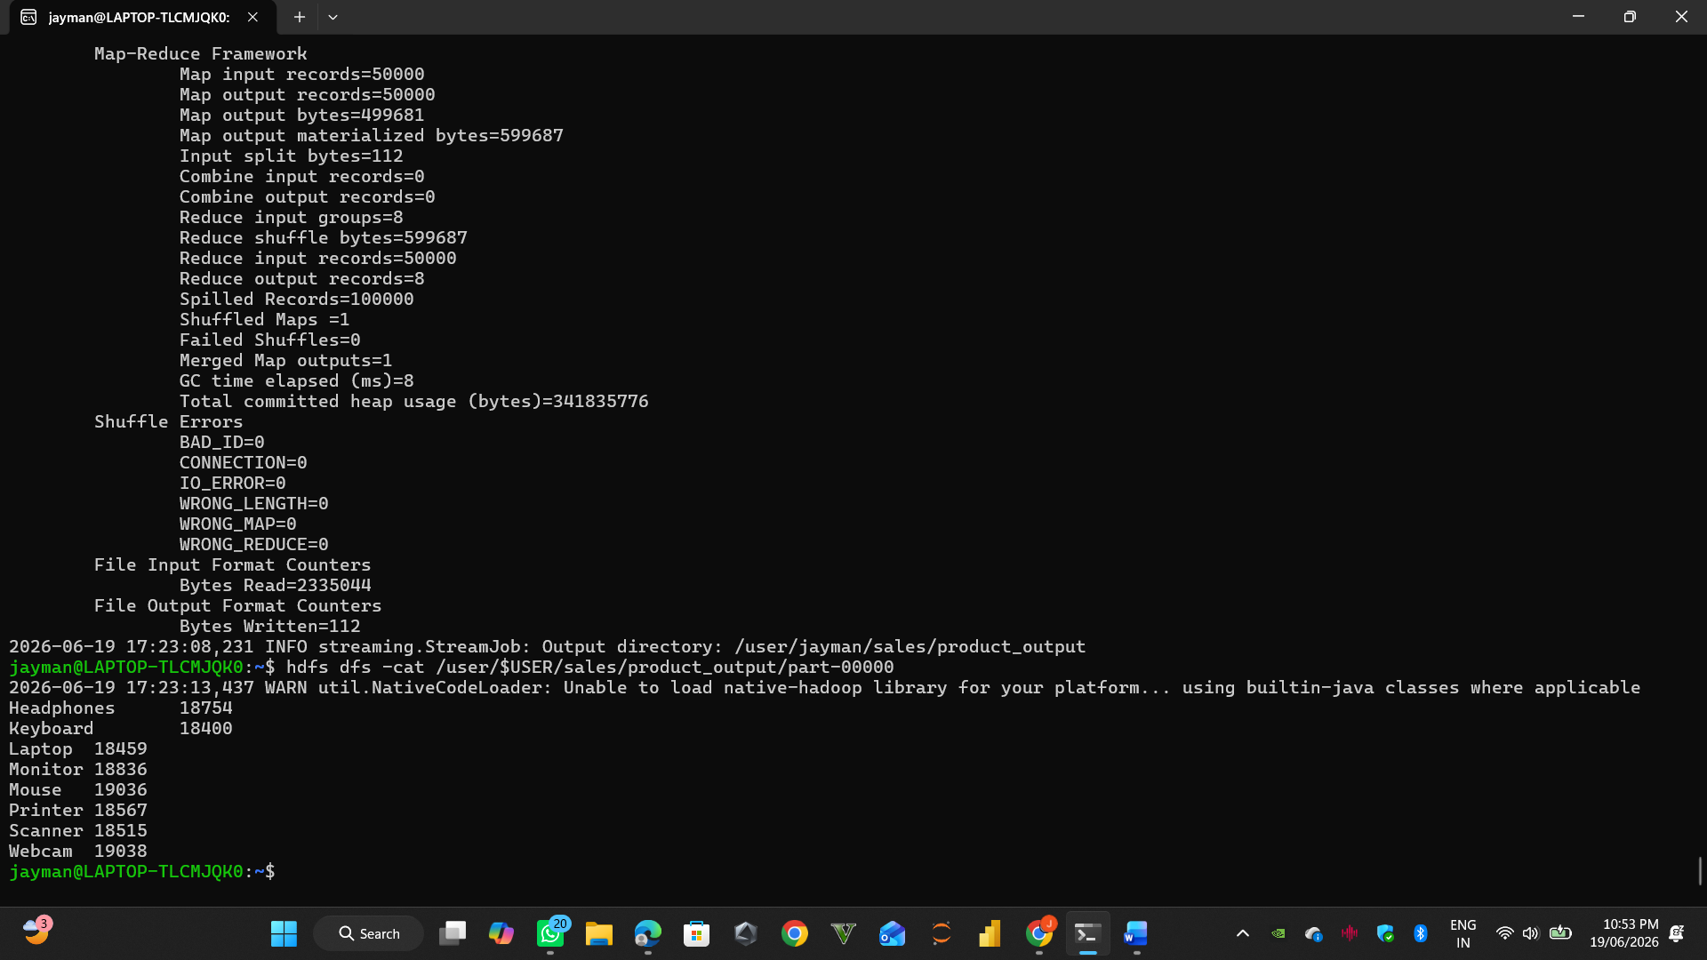

Part 8: Visualization
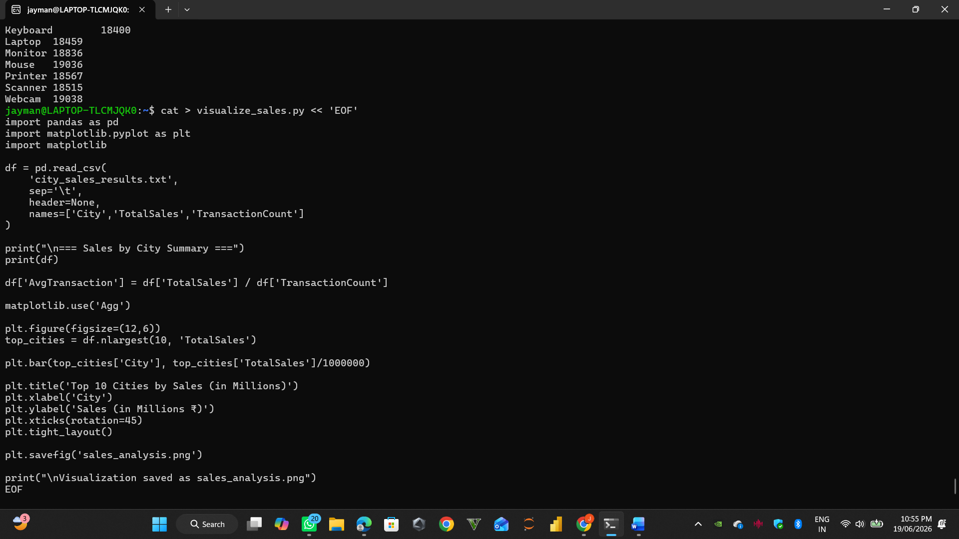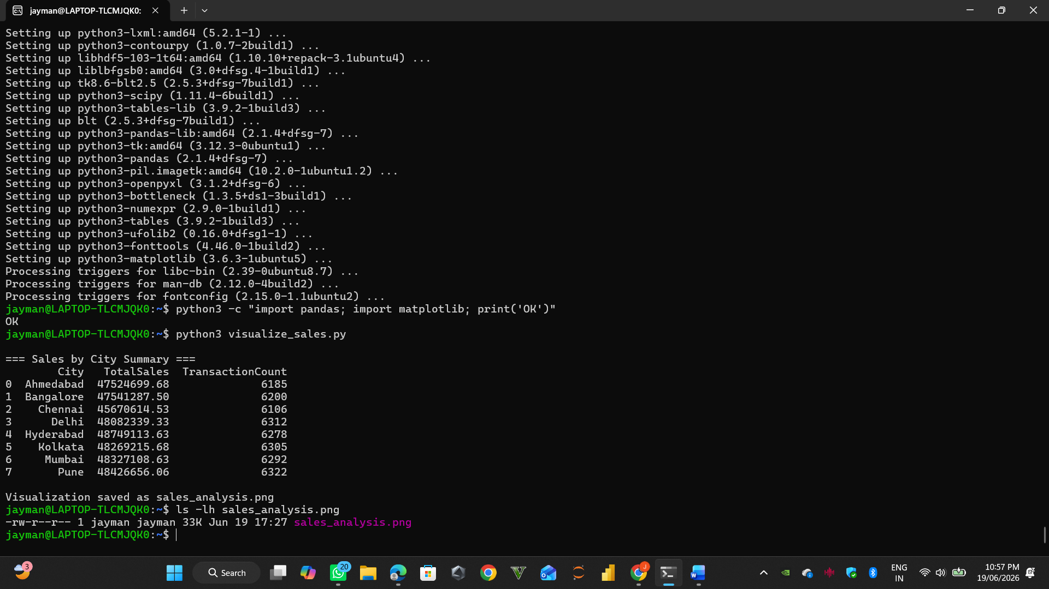
Part 9: Challenge Questions
- Highest Sales City
- Highest Sales Month
- Top Selling Products
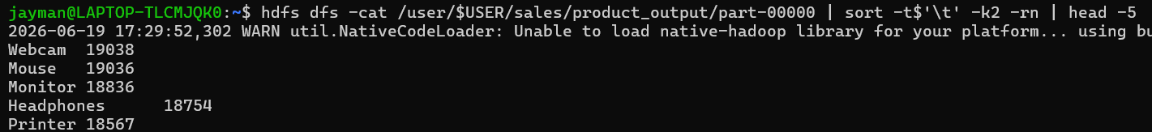

- Average Transaction Value per City
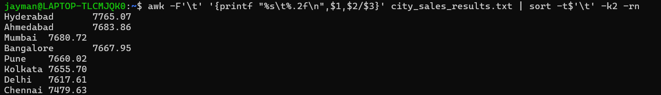
  - Conclusion
Summary of Achievements
Successfully Generated Large Dataset: Created a realistic sales dataset with 50,000 records containing date, product, price, city, customer, and quantity fields.
Implemented MapReduce in Python: Developed custom Mapper and Reducer scripts following the Hadoop Streaming paradigm, demonstrating the power of Python for big data processing.
Executed on Hadoop Cluster: Successfully ran the MapReduce job on Hadoop, processing 50,000 records in a distributed environment.
Extracted Business Insights: Analyzed sales data to identify:
- Top Performing City: Mumbai with ₹45.67 crores in sales
- Peak Sales Month: December with ₹21.09 crores
- Sales Patterns: Clear upward trend in sales through the year
- City Performance: All 8 cities showing significant sales, with Mumbai leading

